BAR CHARTS
Pearson Edexcel - Thursday 4 June 2020 - Paper 2 (Calculator) Foundation Tier

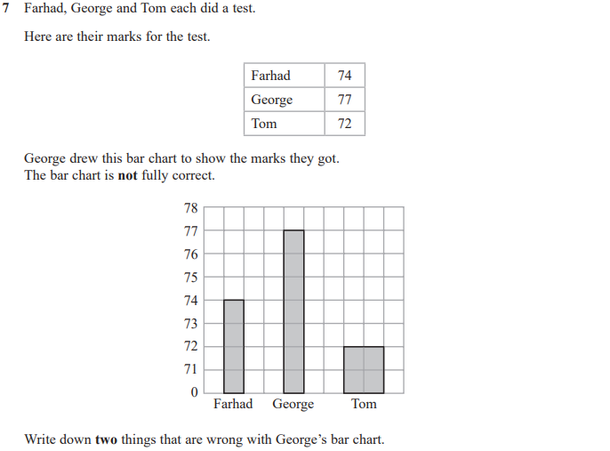
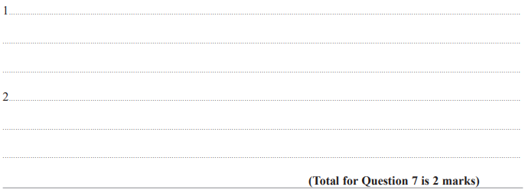

Pearson Edexcel - Thursday 24 May 2018 - Paper 1 (Non-Calculator) Foundation Tier

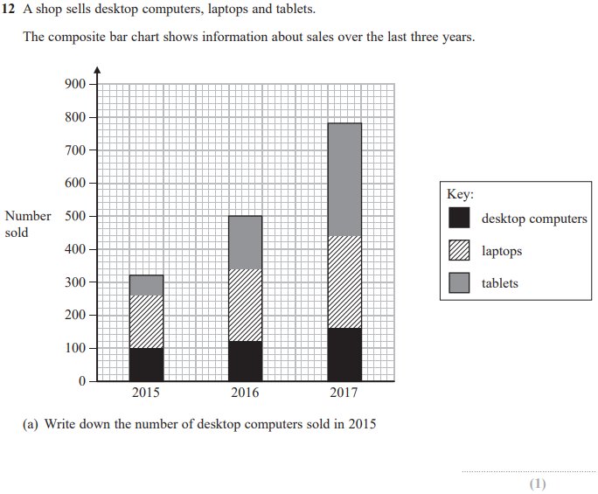
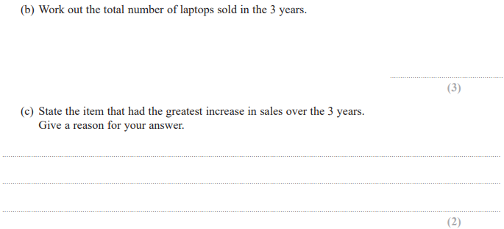
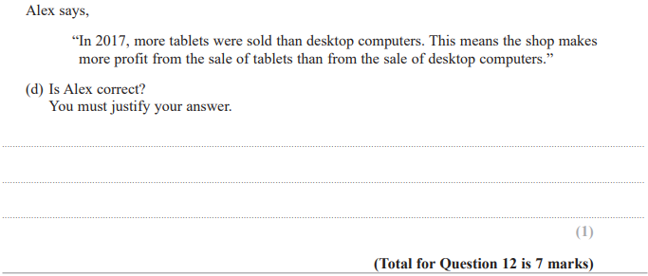

Pearson Edexcel – Specimen 2 - Paper 1 (Non-Calculator) Foundation Tier

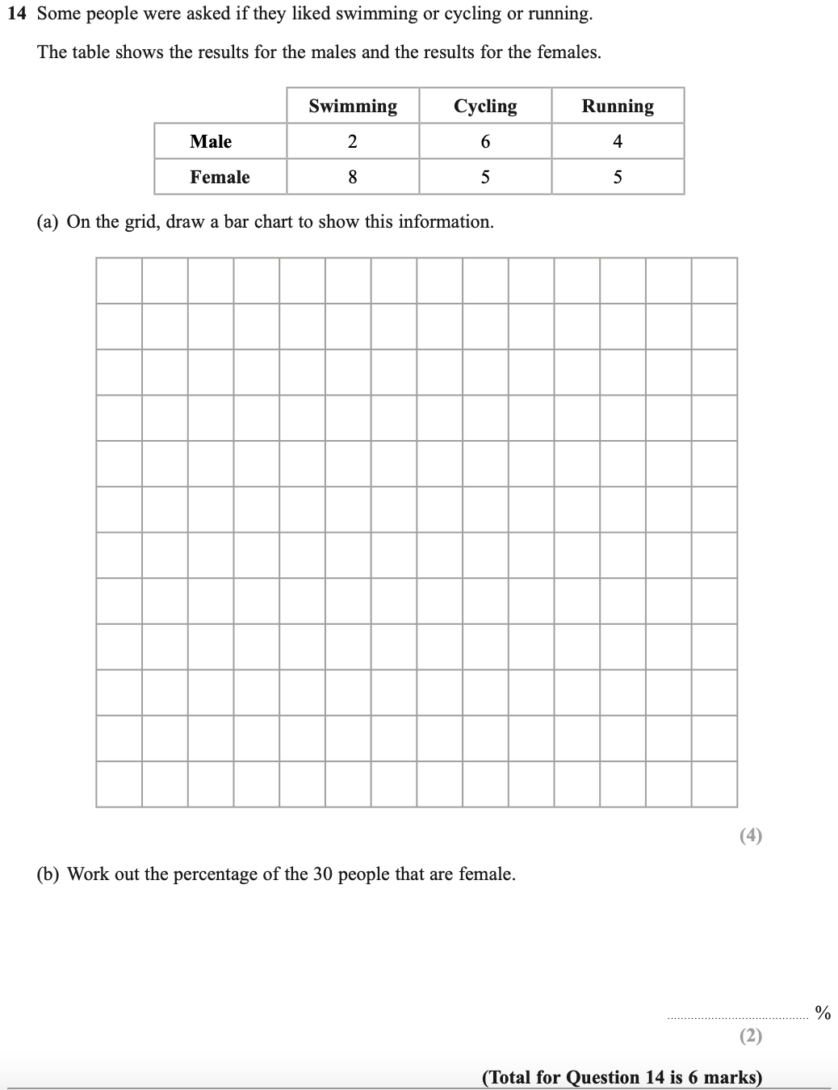
Pearson Edexcel – Specimen 1 - Paper 1 (Non-Calculator) Foundation Tier
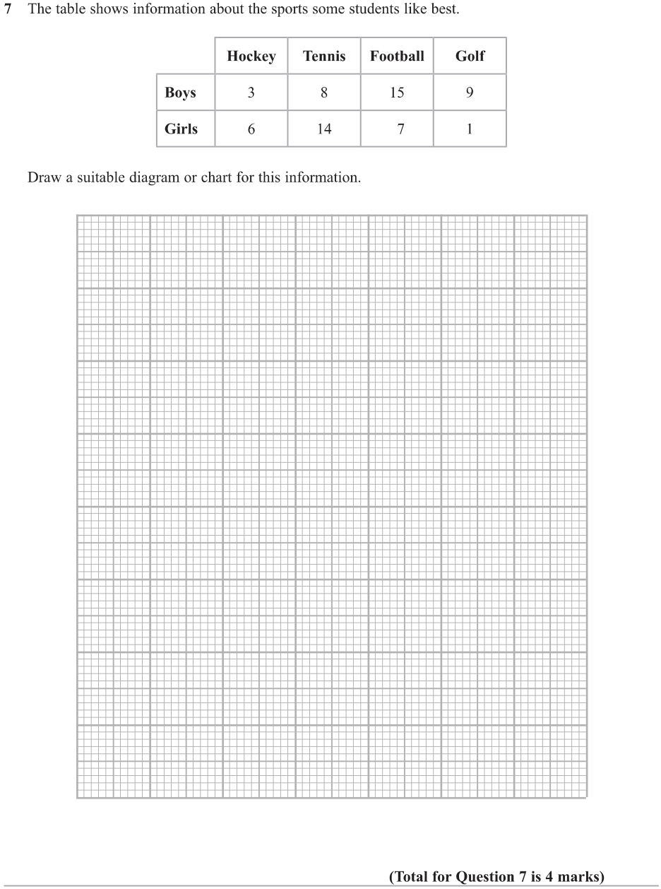

OCR – Tuesday 03 November 2020- Morning - Paper 1 (Calculator) Foundation Tier
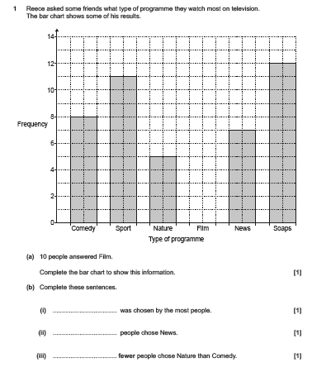

OCR Thursday 05 November 2020- Morning (Non-Calculator) Foundation Tier
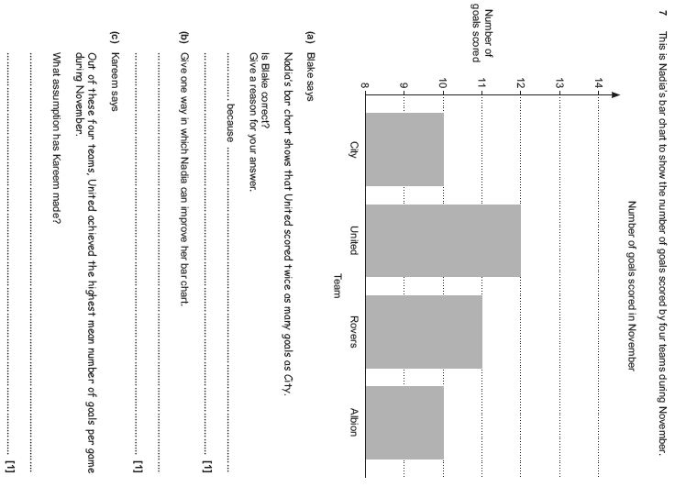

OCR Monday 11 November 2019 – Afternoon (Calculator) Foundation Tier
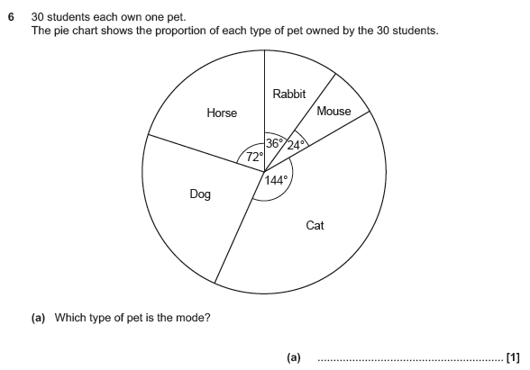

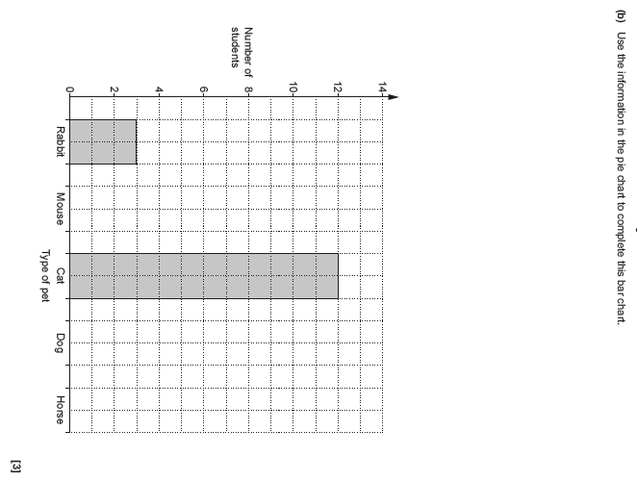

OCR Tuesday 6 November 2018 – Morning (Calculator) Foundation Tier

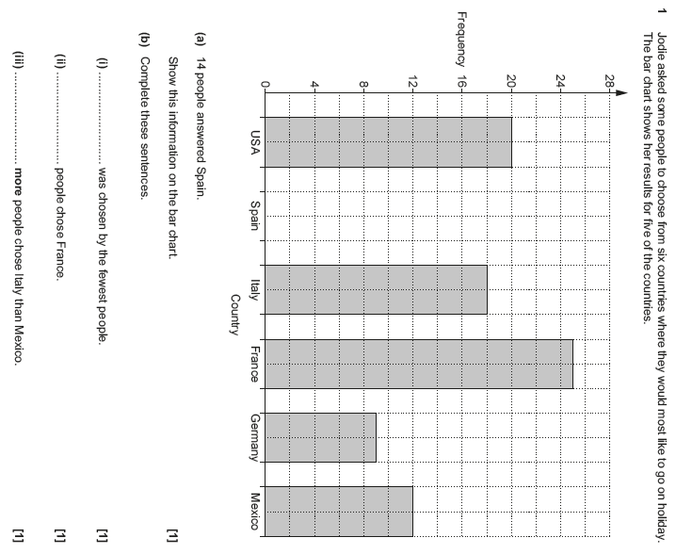

OCR Thursday 7 June 2018 – Morning (Non Calculator) Foundation Tier

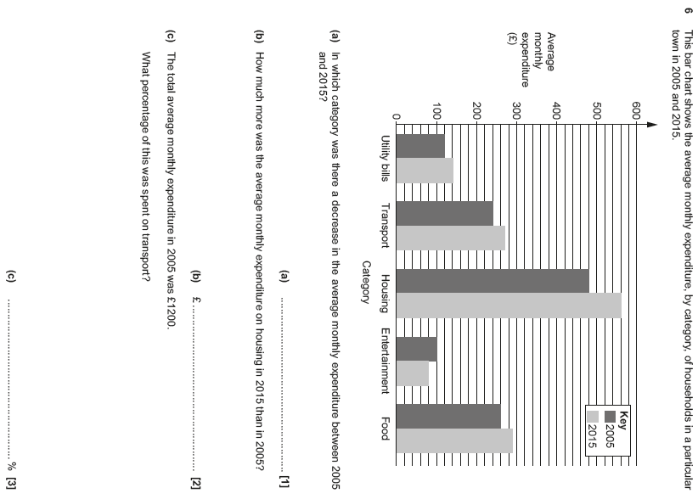

Pearson Edexcel –Sample Papers - Paper 2 (Calculator) Foundation Tier

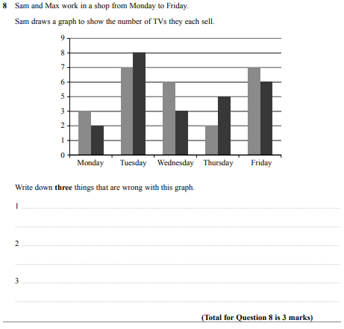

Pearson Edexcel – Sample Papers - Paper 3 (Calculator) Foundation Tier

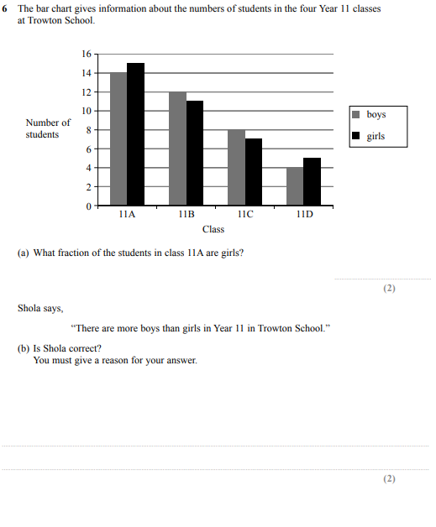

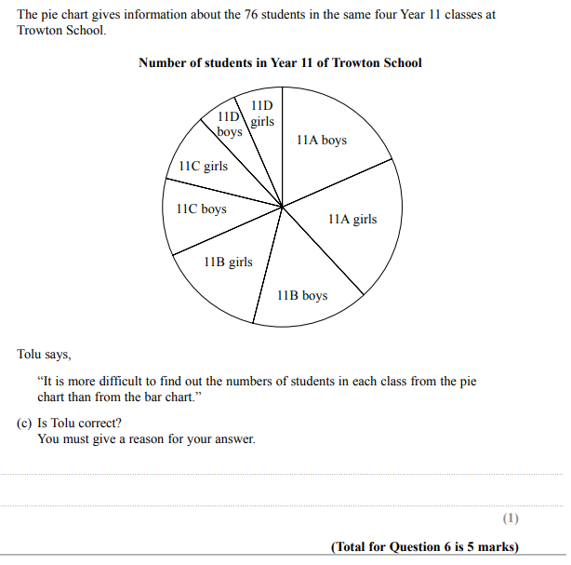

OCR Thursday 8 June 2017 – Morning (Non - Calculator) Foundation Tier

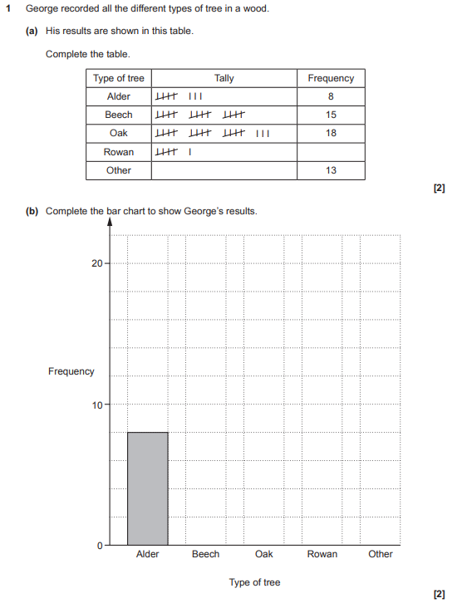

AQA Tuesday 19 May 2020 – Morning (Non-Calculator) Foundation Tier

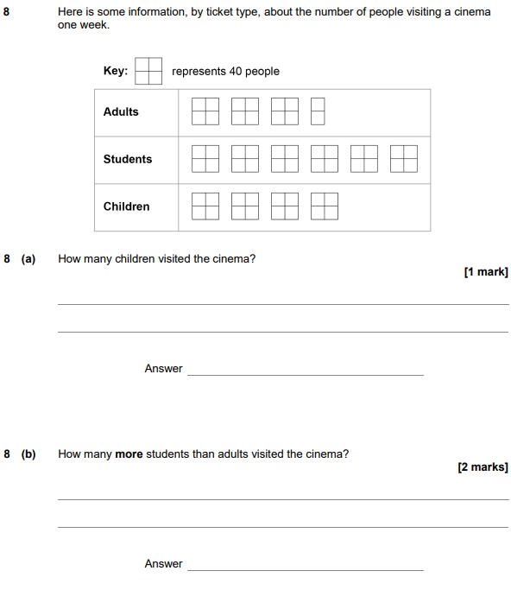

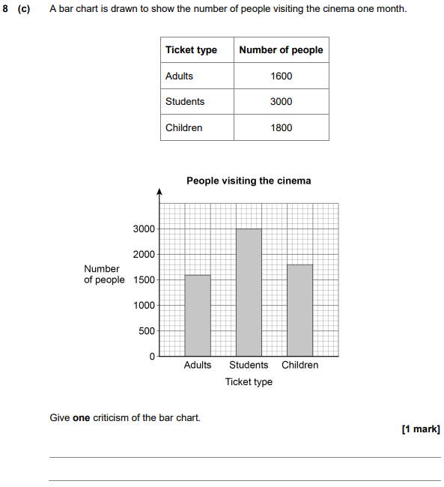

AQA Monday 8 June 2020 – Morning (Calculator) Foundation Tier

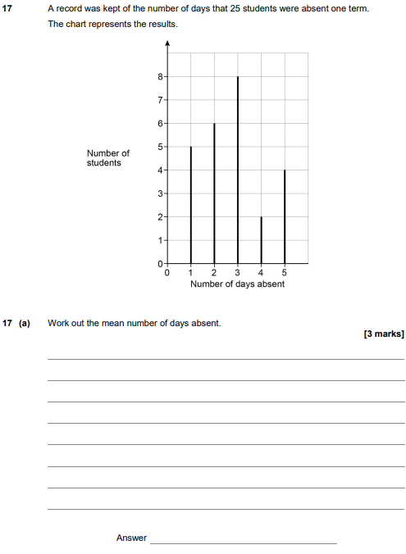

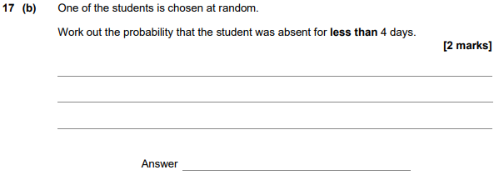

AQA Tuesday 21 May 2019 – Morning (Non-Calculator) Foundation Tier

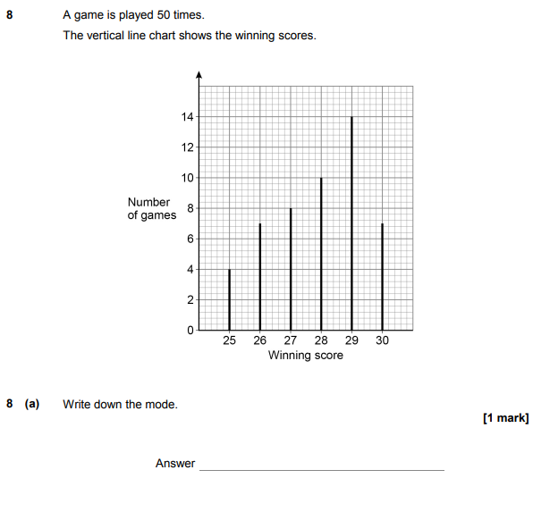
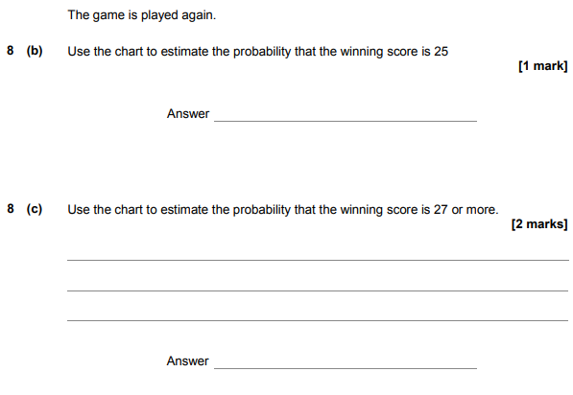

AQA Thursday 6 June 2019 – Morning (Calculator) Foundation Tier

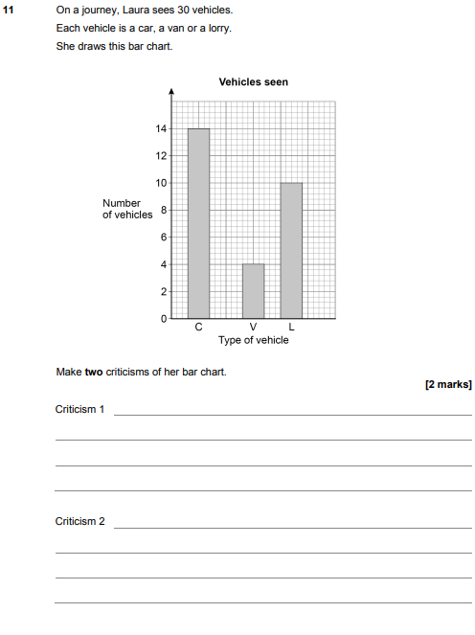

AQA Thursday 8 November 2018 – Morning (Calculator) Foundation Tier

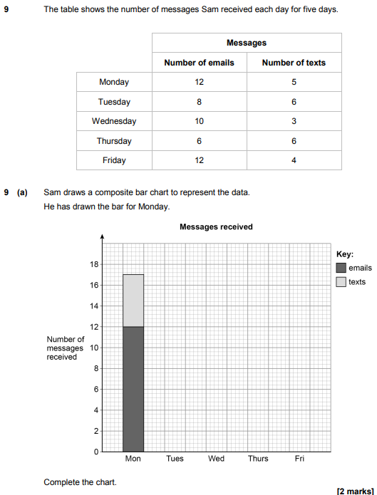
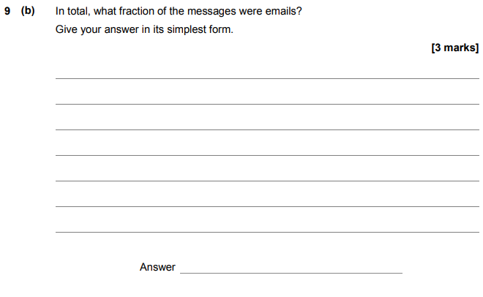

AQA Monday 12 November 2018 – Morning (Calculator) Foundation Tier

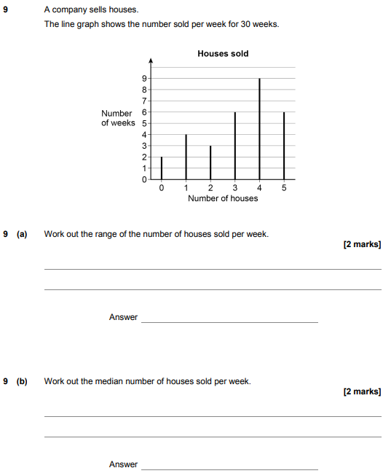

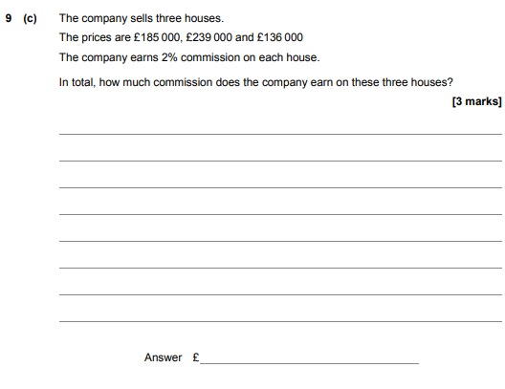

AQA Thursday 2 November 2017 – Morning (Non-Calculator) Foundation Tier

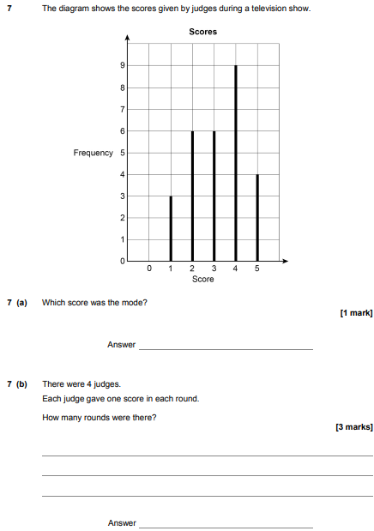

AQA Monday 6 November 2017 – Morning (Calculator) Foundation Tier

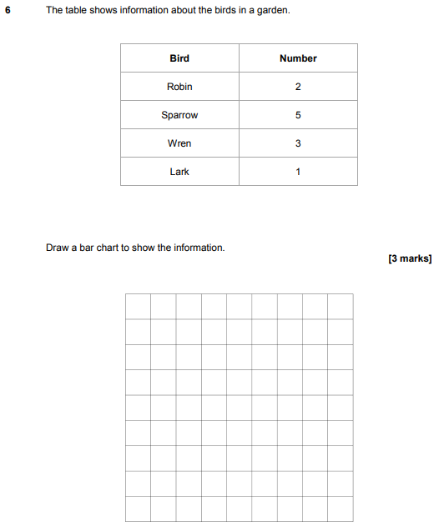

AQA Tuesday 13 June 2017 Morning– Morning (Calculator) Foundation Tier

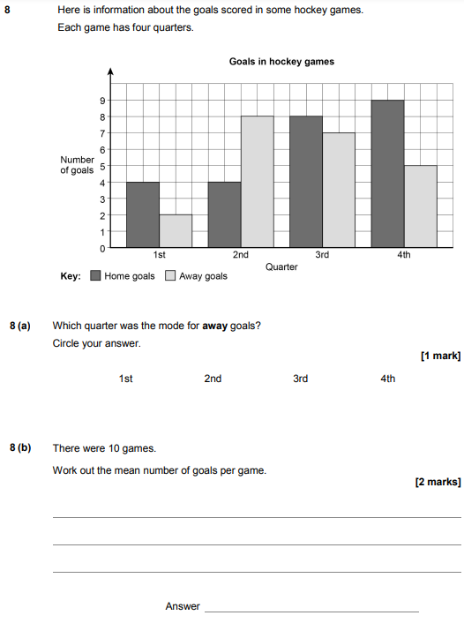
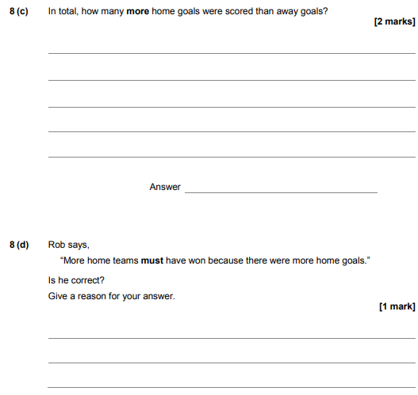

AQA Sample Paper 1– Morning (Non-Calculator) Foundation Tier

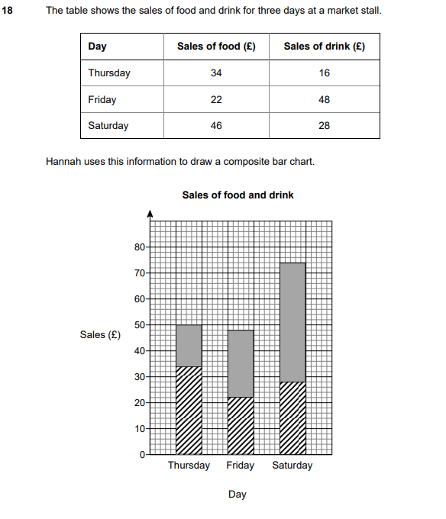
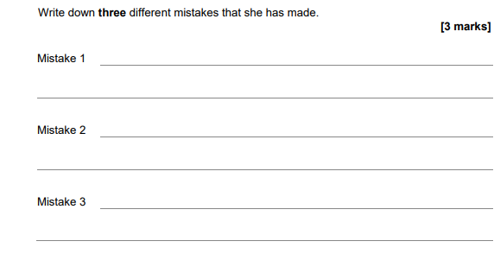

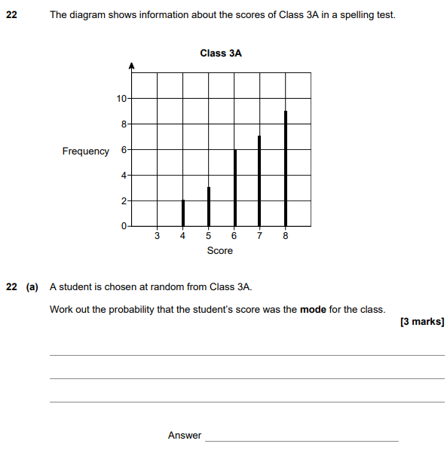
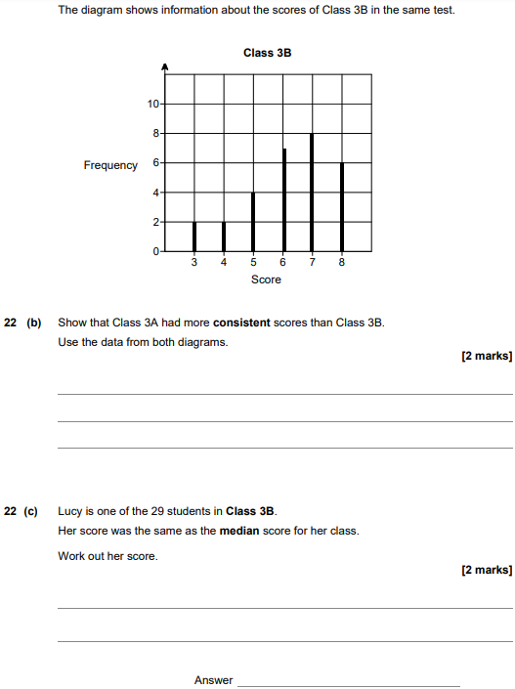

AQA Sample Paper 2– Morning (Calculator) Foundation Tier

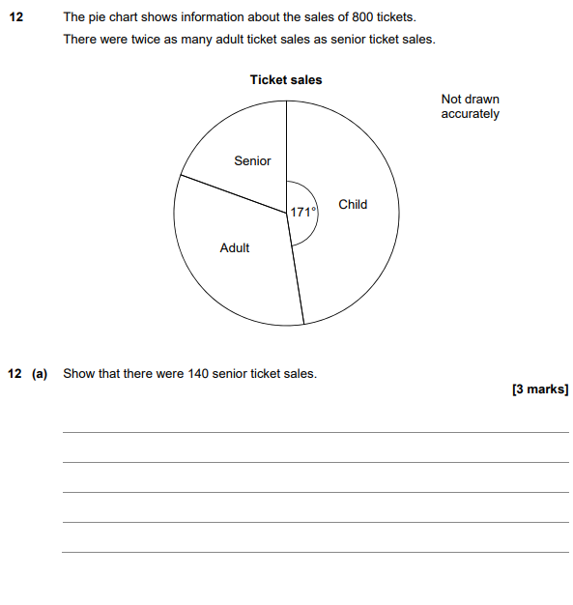
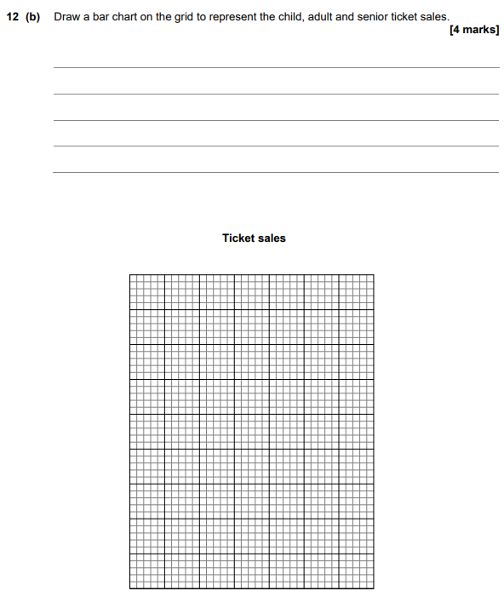

AQA Sample Paper 3– Morning (Calculator) Foundation Tier

